Kerala Finance KIP — Knowledge Intelligence Platform
Finance Policy and Government Order Knowledge Intelligence Platform

Technical Project Documentation
Client: Finance Department, Government of Kerala
Project: Finance Policy and Government Order Knowledge Intelligence Platform
Project Type: Enterprise Document Intelligence and Policy Assistance Platform
Architecture: Local, Modular, Microservice-Based Architecture
Deployment: Docker Compose
AI Approach: Local LLM and Local Embeddings
Frontend: React + Vite
Backend: FastAPI / Python
Document Intelligence: OCR, semantic chunking, hybrid retrieval and extraction
Table of Contents
1. Finance Policy and Government Order Knowledge Intelligence Platform 7
2. Abstract / Executive Summary 8
3. Introduction 10
3.1 Background 10
3.2 Problem Statement 10
3.3 Motivation 11
3.4 Aim 12
3.5 Objectives 12
3.6 Scope 13
4. Requirements Analysis 14
4.1 Functional Requirements 15
4.2 Non-Functional Requirements 20
4.3 User Requirements 21
4.4 System Requirements 22
5. System Analysis and Design 23
5.1 System Architecture 23
5.2 System Workflow 25
5.3 Use-Case Diagram 27
5.4 Data Flow Diagram 28
5.5 UML Design 29
5.6 ER Diagram / Database Design 31
6. Technology Stack 32
6.1 Programming Languages 32
6.2 Frameworks and Libraries 33
6.3 Database and Storage 34
6.4 Development and Deployment Tools 35
7. System Implementation 35
7.1 Repository Structure 35
7.2 API Gateway 37
7.3 Ingestion Service 37
7.4 Semantic Chunking 38
7.5 Embedding Generation 38
7.6 Hybrid Search 38
7.7 Document Lineage 39
7.8 Source Review Labels 40
7.9 Clause and Financial Figure Extraction 40
7.10 GST Assistant 40
7.11 Policy Agent 41
7.12 Local LLM Implementation 41
7.13 Frontend Implementation 42
7.14 Automated Document Classification and Confidence Scoring 42
7.15 Advanced Document Library Filtering 44
7.16 Voice Search / Offline Speech-to-Text Integration 45
7.17 Zero-Trust Security and Secure Vault Viewer 46
7.18 Identity-Aware Real-Time Audit Logging 48
7.19 Traceable Policy Note Agent 49
7.20 GST Policy Assistant with Citation Linking 51
7.21 Operational Analytics Dashboard 52
8. Testing and Validation 52
8.1 Test Strategy 52
8.2 Test Cases 54
8.3 Functional Testing 57
8.4 Error Handling 59
8.5 Performance Testing 60
9. Results and Evaluation 61
9.1 System Demonstration 61
9.2 Automated Document Ingestion Results 63
9.3 Document Library and Filtering Results 63
9.4 Voice Search Results 64
9.5 Hybrid Search and Source-Aware Results 65
9.6 Policy Note Agent Results 65
9.7 GST Assistant Results 66
9.8 Secure Vault and Zero-Trust Results 66
9.9 Identity-Aware Audit Results 67
9.10 Operational Analytics Results 68
9.11 Overall Round 2 Evaluation 68
10. Security, Privacy and Ethical Considerations 70
10.1 Zero-Trust Security Model 70
10.2 Restricted Document Isolation 71
10.3 Secure Vault Viewer 72
10.4 Authentication 72
10.5 Role-Based Access Control 72
10.6 Local AI and Data Privacy 73
10.7 Identity-Aware Audit Logging 73
10.8 Audit and Operational Monitoring 74
10.9 AI Reliability 74
10.10 Ethical Considerations 75
11. Limitations 75
11.1 OCR Accuracy 75
11.2 Classification Accuracy 75
11.3 Speech Recognition Accuracy 75
11.4 Local LLM Resource Requirements 76
11.5 AI Response Accuracy 76
11.6 Document Diversity 76
11.7 Search Evaluation Dataset 76
11.8 Lineage Data Quality 76
11.9 Voice Processing Coverage 76
11.10 Production Scalability 76
11.11 Security Operational Controls 76
12. Future Enhancements 77
12.1 Phase 1 — Current Enterprise-Ready Prototype 77
12.2 Phase 2 — e-Office API Integration 78
12.3 Phase 3 — State-Wide Expansion 78
12.4 Roadmap Summary 79
13. Conclusion 80
14. References 81
15. Appendices 81
Appendix A — Code Snippets 81
Appendix B — Additional Screenshots 83
Appendix C — Configuration Details 87
Appendix D — Sample Input and Output 88
Appendix E — User Role Matrix 92
Appendix F — Main Platform Endpoints 93

1. Finance Policy and Government Order Knowledge Intelligence Platform
Prepared for:
Finance Department, Government of Kerala
Project Objective:
To develop a secure, locally deployable enterprise knowledge intelligence platform for managing, searching, analysing and assisting with Government Orders, circulars, notifications, budget documents and GST policy documents.
Core Technologies:
Python, FastAPI, React, ChromaDB, PostgreSQL, MinIO, Redis, Celery, Ollama, Llama 3.2, sentence-transformers, Tesseract OCR and Docker Compose.

2. Abstract / Executive Summary
The Kerala Finance Knowledge Intelligence Platform (KIP) is an enterprise document-intelligence and policy-assistance platform developed for the Finance Department, Government of Kerala. The platform is designed to manage and analyse large volumes of Government Orders (GOs), circulars, notifications, office memoranda, budget documents and GST policy materials. It provides a secure, locally deployable environment in which government officials can search, verify, analyse and interact with financial policy documents while maintaining document lineage, source traceability and access control.
The platform was initially developed as a Round 1 proof of concept incorporating document ingestion, OCR, hybrid search, document lineage, clause and financial-figure extraction, GST assistance, policy-agent functionality, role-based access control and locally hosted artificial intelligence. Following Round 1 jury feedback, the platform was significantly enhanced for Round 2 to address eight identified areas of improvement and to strengthen its usability, security, traceability and operational capabilities.
The Round 2 implementation introduces an automated document classification and confidence-scoring pipeline. Uploaded documents are automatically analysed to identify key metadata including Authority, Year, Subject and Document Type. A confidence score between 0.0 and 1.0 is assigned to the classification, allowing administrators to identify classifications that require review. Administrators can manually correct low-confidence classifications, with the correction recorded through the audit mechanism. The Document Library has also been enhanced with advanced filtering, enabling users to narrow document collections using attributes such as document type, status and year.
To improve accessibility while preserving the platform's offline architecture, voice-enabled search has been introduced. Officials can dictate search queries through a microphone interface using local speech-recognition functionality without sending government information to external cloud speech-processing services. The platform also introduces a stronger Zero-Trust security model through a Secure Vault Viewer for restricted documents. Restricted documents are hidden from non-administrative users, while administrators access protected content through a tracked viewer in which direct raw-PDF downloading is disabled.

The Round 2 implementation further strengthens auditability by ensuring that audit events are associated with the authenticated user's identity, including username, role and user ID. Search queries, document views and permission-denial events are timestamped and recorded. The Policy Note Agent has also been enhanced to provide a structured workflow that retrieves relevant active Government Orders, verifies their status, extracts relevant financial information and produces a Secretariat-style policy-note draft with traceable source citations and an accompanying disclaimer.
The GST Policy Assistant has similarly been enhanced with clickable source citations, enabling officials to navigate directly to the relevant source document when reviewing GST-related responses. Finally, the Operational Analytics and Audit Dashboard provides real-time visibility into document and operational activity, including total documents, active and superseded orders, restricted-document counts and audit events.
Together, these Round 2 enhancements transform the platform from a document-search proof of concept into a more complete enterprise knowledge-intelligence prototype. The system combines local AI, hybrid information retrieval, document lineage, automated metadata classification, secure document access, voice interaction, traceable policy drafting and operational monitoring while maintaining the principle that sensitive government information remains within the local deployment environment. The updated platform therefore provides a foundation for further integration with government systems and eventual expansion across the wider state administrative environment.

3. Introduction

3.1 Background
Government finance departments manage extensive collections of official documents that influence financial administration, taxation, budgeting and policy implementation. These documents are continuously updated through new Government Orders, amendments, circulars, notifications and policy instructions.
Traditional document-management approaches generally depend on folders, filenames and manual keyword searches. Such approaches become increasingly inefficient when the document collection grows and when users need to understand relationships between different versions of Government Orders.
The challenge becomes more significant when documents are available as scanned PDFs. A normal text-search system cannot effectively search image-based content without an OCR stage (Arslan, 2022). The Kerala Finance KIP addresses this problem by creating a centralized knowledge-intelligence layer capable of processing both scanned and native documents and making their content searchable through natural-language queries. The platform combines conventional information retrieval with modern artificial intelligence techniques while maintaining local processing and source traceability.

3.2 Problem Statement
The Finance Department needs to retrieve authoritative information from large collections of Government Orders, circulars, notifications, budget documents and GST policy materials.
The main problems include:
- Large volumes of documents accumulated over multiple years.
- Documents available in different formats.
- Scanned PDFs requiring OCR.
- Difficulty identifying the latest or active version of an order.
- Risk of relying on superseded Government Orders.
- Difficulty locating specific clauses and financial figures.
- Time-consuming manual policy research.
- Difficulty connecting information across related documents.
- Need for secure access to restricted documents.
- Need for traceable and evidence-based AI responses.
- Privacy concerns associated with sending government documents to external AI services.
Therefore, a secure knowledge platform is required that can ingest, process, index and retrieve documents while preserving document lineage and providing controlled AI-assisted policy research.

3.3 Motivation
The primary motivation is to reduce the time and effort required for government officials to locate and interpret relevant financial and policy information.
The system is particularly motivated by the following needs:
- Faster information retrieval
Officials should be able to ask natural-language questions instead of manually searching large document collections.
- Improved information accuracy
Search results should identify relevant source documents and provide page-level provenance.
- Version awareness
Superseded Government Orders should be identified and excluded when appropriate.
- Support for scanned documents
OCR allows image-based government documents to become searchable.
- Secure AI assistance
A local LLM avoids unnecessary transmission of sensitive information to external AI providers.
- Policy research automation
The policy agent can retrieve relevant documents, verify their status and support policy-note preparation.
- Auditability
Important platform activities can be recorded for accountability and review.

3.4 Aim
The aim of the project is to develop a secure, locally deployable knowledge intelligence platform that enables the Finance Department to ingest, search, analyse and interact with Government finance and policy documents using hybrid information retrieval and locally hosted artificial intelligence.

3.5 Objectives
The primary objective of Kerala Finance KIP is to provide a secure, locally deployable knowledge-intelligence platform that enables government officials to efficiently discover, verify and use financial and policy information contained within Government Orders, circulars, budget documents and GST-related materials.
Following the Round 1 evaluation, the Round 2 implementation extends this objective through the following specific goals:
- Automated Document Classification
Develop an automated classification pipeline capable of identifying important document metadata, including Authority, Year, Subject and Document Type, when new documents are ingested.
- Classification Confidence Scoring
Assign a measurable confidence score to automated classifications so that administrators can identify potentially uncertain classifications and manually review them where necessary.
- Advanced Document Discovery
Provide granular Document Library filtering so that officials can locate relevant documents using combinations of metadata such as document type, status and year.
- Offline Voice Interaction
Provide a locally processed voice-search capability that allows officials to dictate natural-language queries without transmitting government information to external speech-recognition services.
- Zero-Trust Document Security
Strengthen role-based access control so that restricted documents are excluded from the accessible document and AI-search context of unauthorized users.
- Secure Restricted-Document Viewing
Provide an administrator-controlled Secure Vault Viewer for restricted documents, with tracked access and disabled raw-PDF downloading.
- Identity-Aware Audit Logging
Record system actions against the authenticated user's identity, including user ID, username, role, action and timestamp, to strengthen accountability and auditability.
- Traceable Policy-Note Generation
Improve the Policy Note Agent so that it retrieves relevant active sources, verifies document status, extracts supporting information and generates a structured Secretariat-style policy-note draft with traceable citations.
- Verifiable GST Policy Assistance
Enhance the GST Policy Assistant with direct source citations so that users can verify responses against the corresponding official policy documents.
- Operational Monitoring
Provide an operational analytics dashboard that presents document statistics and audit activity in a consolidated interface for administrative monitoring.
- Maintain Local Data Processing
Preserve the platform's local and air-gapped processing architecture so that sensitive government documents, embeddings and AI interactions remain within the controlled deployment environment.
- Support Enterprise Expansion
Establish an architectural foundation that can subsequently support integration with e-Office systems and wider state-level deployment.
The Round 2 presentation describes these enhancements as the response to the eight specific areas identified during the Round 1 evaluation.

3.6 Scope
In Scope
The project includes:
- PDF document ingestion.
- Scanned PDF detection.
- Tesseract-based OCR.
- Native PDF text extraction.
- Document parsing.
- Semantic chunking.
- Local embedding generation.
- ChromaDB vector indexing.
- BM25 keyword indexing.
- Hybrid search.
- RRF reranking.
- Document lineage tracking.
- Source citations.
- Clause extraction.
- Financial figure extraction.
- GST policy assistance.
- Policy-note agent.
- Local LLM question answering.
- User authentication.
- Role-based access control.
- Restricted document isolation.
- Audit logging.
- Analytics.
- React-based user interface.
- REST/WebSocket communication.
- Docker Compose deployment.
- Automated tests.
Out of Scope
The POC does not attempt to replace official government decision-making systems (Chen et al., 2024). AI-generated outputs are intended to assist users with research and drafting rather than independently make legally binding policy decisions.

4. Requirements Analysis

4.1 Functional Requirements
FR1 — Document Upload
The system shall allow authorized users to upload finance and policy documents.
FR2 — Document Detection
The system shall determine whether a PDF is native text-based or requires OCR processing.
FR3 — OCR
The system shall process scanned documents using Tesseract OCR.
FR4 — Document Parsing
The system shall extract text and relevant structural information from native PDFs.
FR5 — Semantic Chunking
Documents shall be divided into meaningful content chunks while maintaining page-level provenance.
FR6 — Embedding Generation
The system shall generate embeddings using a local sentence-transformers model.
FR7 — Vector Search
The system shall store document embeddings in ChromaDB and support semantic retrieval.
FR8 — Keyword Search
The system shall support BM25 keyword-based retrieval.
FR9 — Hybrid Search
The system shall combine semantic and keyword search results.
FR10 — Reranking
The system shall apply Reciprocal Rank Fusion to combine retrieval rankings.
FR11 — Document Lineage
The system shall maintain relationships between Government Orders, including supersession relationships.
FR12 — Source Verification
Search and AI responses shall provide source review information, including document, page, confidence and status.
FR13 — AI Question Answering
The system shall provide AI-assisted responses using the local Ollama LLM.
FR14 — Clause Extraction
Authorized users shall be able to extract relevant clauses from documents.
FR15 — Financial Figure Extraction
The system shall support extraction of financial figures from relevant documents.
FR16 — GST Assistant
The platform shall provide GST policy research and rate lookup capabilities.
FR17 — Policy Agent
The system shall provide multi-step assistance for policy-note drafting.
FR18 — Authentication
Users shall authenticate before accessing protected functionality.
FR19 — Role-Based Access Control
The platform shall enforce different permissions for Admin, Analyst and Viewer users.
FR20 — Audit Logging
Important system actions shall be recorded for audit purposes.
FR21 — Analytics
The platform shall provide usage and system metrics.
FR22 — Automated Document Classification
The system shall automatically classify uploaded documents by extracting relevant metadata including:
- Authority
- Year
- Subject
- Document Type
The classification process shall execute as part of the document-ingestion workflow.
FR23 — Classification Confidence Scoring
The system shall assign a confidence score between 0.0 and 1.0 to the automated classification result and display the score to authorized users in a human-readable percentage format.
For example:
- Confidence Score: 0.97
- Displayed Confidence: 97%
Administrators shall be able to manually correct classifications when the confidence level or classification result is considered unsuitable. Manual correction shall be recorded in the audit trail.
The Round 2 presentation specifically demonstrates automated metadata extraction and confidence scoring on the Intelligent Document Processing page.
FR24 — Offline Voice Search
The system shall provide a microphone-based search interface that allows authorized users to dictate natural-language queries.
Speech processing shall operate locally without requiring an external cloud speech-recognition API.
The resulting text shall be passed to the existing document-search workflow.
The Round 2 implementation introduces this capability specifically to provide offline audio interaction while maintaining the platform's local processing requirements.
FR25 — Secure Vault Viewer
The system shall provide a secure viewer for restricted documents.
Restricted documents shall:
- Be hidden from unauthorized users.
- Not appear in unauthorized search results.
- Not be included in unauthorized AI context.
- Be accessible only to appropriately authorized users.
- Be displayed through a controlled internal viewer.
- Prevent direct raw-PDF downloading.
- Access to restricted content shall generate an audit event.
The Round 2 presentation identifies the Secure Viewer as part of the Zero-Trust security implementation.
FR26 — Advanced Document Filtering
The Document Library shall provide granular filtering functionality.
Users shall be able to filter documents using supported metadata fields including:
- Document Type
- Status
- Year
The filtering mechanism shall support the narrowing of large document collections to relevant records.
FR27 — Identity-Aware Audit Logging
The system shall associate audit events with the authenticated user's:
- User ID
- Username
- Role
- Action
- Timestamp
The system shall record significant activities including searches, document views and permission denials.
FR28 — Traceable Policy Note Generation
The Policy Note Agent shall generate a structured policy-note response containing:
- Agent execution steps
- Retrieved source information
- Verification information
- Policy-note draft
- Disclaimer
- Clickable source citations
The workflow shall prioritize active and verified Government Orders.
FR29 — GST Citation Linking
The GST Policy Assistant shall provide clickable citations to the official source documents supporting GST-related responses.
FR30 — Operational Analytics Dashboard
The system shall provide an operational dashboard displaying relevant platform statistics, including:
- Total documents
- Active orders
- Superseded orders
- Restricted documents
- Audit events
- User/action information
- Timestamps
The Round 2 presentation demonstrates this capability through the Operational Analytics and Audit Drill-Down interface.

4.2 Non-Functional Requirements
Security
- The system must protect restricted documents and prevent unauthorized access.
Privacy
- Sensitive documents and AI prompts should remain within the local deployment environment.
Performance
- Search operations should provide useful results within an acceptable response time for an enterprise POC.
Reliability
- The system should handle invalid documents, failed OCR operations and service failures without crashing the entire platform.
Maintainability
- Services should have clear boundaries and independently maintainable code.
Scalability
- The microservice structure should allow individual services to scale independently.
Auditability
- Important actions should be traceable through audit records.
Usability
- Users should be able to search and interact with the platform through a clear web interface.
Portability
- The application should be deployable using Docker Compose.
Explainability
- AI-generated information should be associated with source documents and review labels.

4.3 User Requirements
Administrator
The Administrator requires:
- Access to all documents, including restricted documents.
- Search access.
- Extraction capabilities.
- Policy-agent access.
- GST functionality.
- User and system administration.
- Audit visibility.
Analyst
The Analyst requires:
- Access to non-restricted documents.
- Search.
- Document extraction.
- GST assistance.
- Policy-agent functionality.
- Research and analysis features.
Viewer
The Viewer requires:
- Access to non-restricted documents.
- Search functionality.
- Read-only access to knowledge resources.
The Viewer does not have extraction, agent or administration privileges.

4.4 System Requirements
Hardware
Recommended minimum configuration:
- RAM: 8 GB minimum.
- RAM: 16 GB recommended when running the local LLM.
- Disk space: at least 20 GB.
- Modern multi-core CPU.
- Additional resources may be required depending on document volume and LLM workload.
Software
- Docker Desktop 24+
- Docker Compose v2
- Git
- Python 3.11 where local development is required.
- Modern web browser.

5. System Analysis and Design

5.1 System Architecture
The system follows a four-tier architecture.
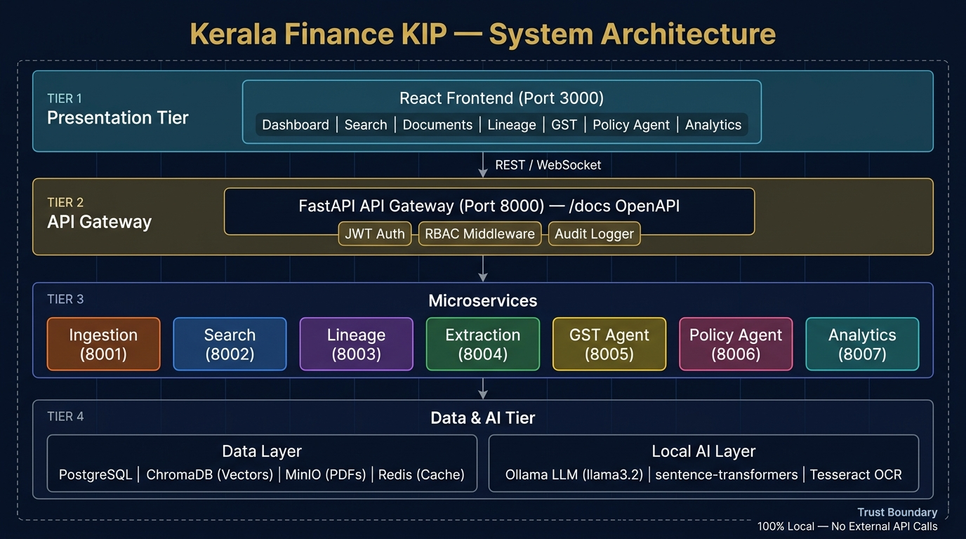
Figure 1: System Architecture
(Source: Self-created)
Tier 1 — Presentation Layer
The presentation layer is implemented using React and Vite.
It provides:
- Dashboard.
- Search.
- Documents.
- Lineage.
- GST assistant.
- Policy agent.
- Analytics.
The frontend communicates with the backend through REST and WebSocket interfaces.
Tier 2 — API Gateway
FastAPI acts as the central API gateway.
The gateway provides:
- API routing.
- JWT authentication.
- RBAC middleware.
- Audit middleware.
- Rate limiting.
- OpenAPI documentation.
The API gateway prevents direct uncontrolled access to internal services.
Tier 3 — Microservice Layer
The application contains separate services:
Service | Purpose
Ingestion Service | Document processing and OCR
Search Service | Hybrid retrieval and answer generation
Lineage Service | Version and supersession tracking
Extraction Service | Clause and figure extraction
GST Agent | GST research assistance
Policy Agent | Policy-note drafting
Analytics Service | Metrics and audit-related analytics
Tier 4 — Data and AI Layer
The data and AI layer contain:
- PostgreSQL — metadata and audit-related information.
- ChromaDB — vector storage.
- MinIO — document storage.
- Redis — caching and task coordination.
- Ollama — local LLM execution.
- sentence-transformers — local embeddings.
- Tesseract — OCR.
This architecture provides clear separation between the user interface, security boundary, application services and data/AI components.

5.2 System Workflow
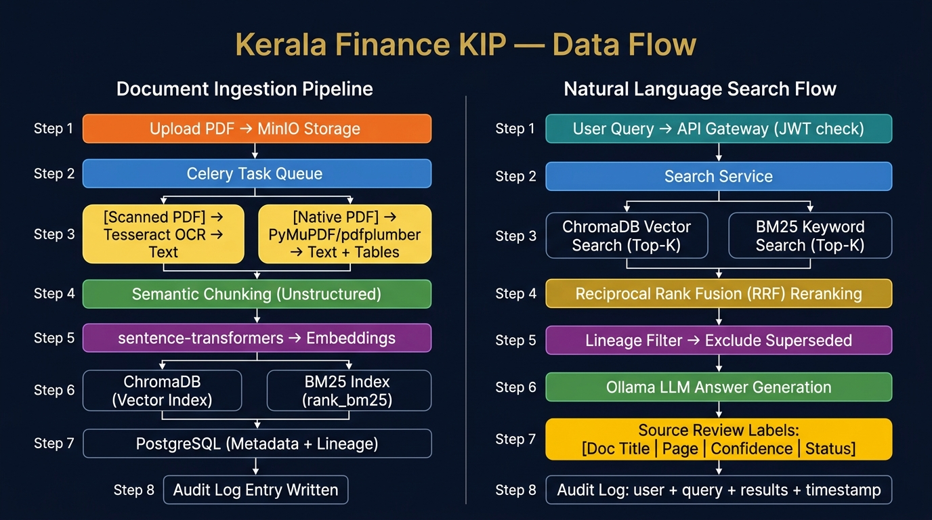
Figure 2: Data Flow Diagram
(Source: Self-created)
Document Ingestion Workflow
- The user uploads a PDF.
- The document is stored in MinIO.
- A Celery task is created.
- The system determines whether the PDF is scanned or native.
- Scanned PDFs are processed through Tesseract OCR.
- Native PDFs are processed through PyMuPDF/pdfplumber.
- Extracted content is processed using document parsing.
- The document is semantically chunked.
- Page-level provenance is maintained.
- Local embeddings are generated.
- Embeddings are stored in ChromaDB.
- Keyword-search information is indexed using BM25.
- Metadata and lineage information are stored in PostgreSQL.
- An audit entry is created.
Search Workflow
- The user submits a natural-language query.
- API Gateway validates the user's JWT.
- RBAC determines accessible documents.
- Search service performs semantic search.
- BM25 performs keyword search.
- Results are combined through RRF.
- Lineage filtering identifies superseded sources.
- Relevant sources are passed to the local LLM.
- The LLM generates an answer.
- Source review labels are attached.
- Search and audit information is recorded.

5.3 Use-Case Diagram
The principal actors are:
- Administrator.
- Analyst.
- Viewer.
Administrator Use Cases
- Login.
- Search documents.
- Upload documents.
- Extract clauses.
- Extract financial figures.
- View document lineage.
- Use a GST assistant.
- Use a policy agent.
- View analytics.
- Access restricted documents.
- Manage system functionality.
Analyst Use Cases
- Login.
- Search documents.
- View documents.
- Extract information.
- View lineage.
- Use a GST assistant.
- Use a policy agent.
- Review source citations.
Viewer Use Cases
- Login.
- Search documents.
- View permitted documents.
- Review source information.
The authorization layer ensures that each actor can access only the functionality assigned to the relevant role.

5.4 Data Flow Diagram
The platform has two major data flows.
A. Document Ingestion Data Flow
PDF Upload
↓
MinIO Storage
↓
Celery Task Queue
↓
Scanned PDF → Tesseract OCR
or
Native PDF → PyMuPDF/pdfplumber
↓
Semantic Chunking
↓
Local Embeddings
↓
ChromaDB + BM25
↓
PostgreSQL Metadata and Lineage
↓
Audit Log
B. Natural Language Search Flow
User Query
↓
API Gateway / JWT Check
↓
Search Service
↓
ChromaDB Semantic Search + BM25 Keyword Search
↓
Reciprocal Rank Fusion
↓
Lineage Filter
↓
Ollama Local LLM
↓
Source Review Labels
↓
Audit Log

5.5 UML Design
The main UML relationships can be represented through the following components.
Component Relationships
User → React Frontend → FastAPI Gateway → Microservice → Data/AI Layer
The API Gateway acts as the controlled entry point.
Sequence — Document Search
- The user enters a query.
- React sends requests to FastAPI.
- FastAPI authenticates the user.
- RBAC determines access.
- Search service receives the query.
- ChromaDB and BM25 retrieve candidate results.
- RRF combines rankings.
- Lineage service checks document status.
- Search service passes validated context to Ollama.
- Ollama generates an answer.
- Source metadata is returned.
- The audit service records the operation.
- React displays the answer and sources.
Sequence — Document Ingestion
- Administrator uploads a PDF.
- API Gateway validates permissions.
- The document is stored in MinIO.
- Celery schedules processing.
- OCR or native parser extracts content.
- Content is chunked.
- Embeddings are generated.
- ChromaDB receives vector records.
- BM25 index is updated.
- PostgreSQL stores metadata and lineage.
- An audit record is created.

5.6 ER Diagram / Database Design
PostgreSQL is used as the primary metadata database.
Important logical entities include:
User
- user_id
- username
- password/security information
- role
- status
Document
- document_id
- title
- document_type
- file_path/reference
- upload_date
- status
- access classification
Document Version / Lineage
- lineage_id
- document_id
- supersedes_document_id
- relationship_type
- effective status
Document Chunk
- chunk_id
- document_id
- page_number
- chunk_text
- embedding reference
Audit Log
- audit_id
- user_id
- action
- IP information
- timestamp
- status
- query/result information where applicable
Search / Interaction Record
- interaction_id
- user_id
- query
- timestamp
- retrieved sources
- response status
ChromaDB stores the vector representations required for semantic retrieval, while MinIO stores source documents.

6. Technology Stack

6.1 Programming Languages
Python 3.11
Python is the primary backend language and is used for:
- FastAPI services.
- OCR pipeline.
- Document processing.
- Search.
- Embedding generation.
- AI integration.
- Agents.
- Analytics.
- Testing.
JavaScript
JavaScript is used for the React frontend and user interaction.
CSS
CSS is used for frontend styling.

6.2 Frameworks and Libraries
Technology | Purpose
FastAPI | Backend API framework
React | Frontend UI
Vite | Frontend build tooling
Ollama | Local LLM execution
Llama 3.2 | Local language model
LangChain | Agent orchestration
sentence-transformers | Embeddings
ChromaDB | Vector database
rank_bm25 | Keyword retrieval
Tesseract | OCR
PyMuPDF | PDF processing
pdfplumber | PDF extraction
Unstructured | Document parsing
Celery | Asynchronous task processing
Redis | Cache/task coordination
Chart.js | Analytics visualisation

6.3 Database and Storage
PostgreSQL
Used for:
- Metadata.
- User-related information.
- Document relationships.
- Audit information.
- Lineage.
ChromaDB
Used for:
- Vector embeddings.
- Semantic retrieval.
- Restricted-document collection isolation.
MinIO
Used as a local S3-compatible document store for PDF files.
Redis
Used for caching and task coordination.

6.4 Development and Deployment Tools
- Git/GitHub.
- Docker.
- Docker Compose.
- Makefile.
- Pytest.
- OpenAPI/Swagger.
- Nginx.
- VS Code or equivalent development environment.

7. System Implementation

7.1 Repository Structure
The implementation follows a modular repository structure:
kerala-finance-kip/
├── docker-compose.yml
├── Makefile
├──. env.example
├── services/
│ ├── api-gateway/
│ ├── ingestion-service/
│ ├── search-service/
│ ├── lineage-service/
│ ├── extraction-service/
│ ├── gst-agent-service/
│ ├── policy-agent-service/
│ └── analytics-service/
├── frontend/
├── data/sample_documents/
├── scripts/
├── tests/
├── nginx/
└── docs/

This structure separates the platform into logical service boundaries.

7.2 API Gateway
The API Gateway is implemented using FastAPI.
Its main responsibilities are:
- Routing.
- Authentication.
- Authorization.
- RBAC.
- Audit middleware.
- Rate limiting.
- API documentation.
The gateway exposes an OpenAPI interface, allowing developers and administrators to inspect available endpoints.

7.3 Ingestion Service
The ingestion service handles document upload and processing.
The pipeline automatically determines whether a document requires OCR.
Native PDF
Native PDFs are processed using:
- PyMuPDF.
- pdfplumber.
Scanned PDF
Scanned PDFs are processed through:
- Image preprocessing.
- Tesseract OCR.
The extracted content is then passed to semantic chunking.

7.4 Semantic Chunking
Large documents are divided into smaller meaningful sections.
Chunk metadata preserves information such as:
- Document ID.
- Page number.
- Source document.
- Content type.
- Lineage information.
This enables the search system to retrieve specific sections instead of returning entire documents.

7.5 Embedding Generation
The system uses a local sentence-transformer model to generate vector representations. The purpose of embeddings is to represent semantic meaning rather than relying only on exact words (Aceves and Evans, 2023).
For example, a query about:
"financial assistance for government employees"
may retrieve relevant content even when the exact phrase does not appear in the source document.

7.6 Hybrid Search
The platform combines two retrieval methods.
Semantic Search
ChromaDB retrieves documents based on embedding similarity.
Keyword Search
BM25 retrieves documents based on lexical relevance.
Reciprocal Rank Fusion
The two ranked lists are combined using Reciprocal Rank Fusion.
Conceptually:
RRF(d) = Σ 1 / (k + rank_i(d))
where:
- d is a document.
- rank_i(d) is the document's rank in retrieval system i.
- k is a ranking constant.
This allows the system to benefit from both semantic similarity and exact keyword matching.

7.7 Document Lineage
Document lineage is one of the most important features of the platform.
Government Orders may be superseded by newer orders. The platform maintains these relationships.
Example:
GO(Ms) No.45/2023/Fin [SUPERSEDED]
↓
superseded by
↓
GO(Ms) No.112/2023/Fin [ACTIVE]
During search and policy assistance, lineage information is used to prevent obsolete documents from being incorrectly presented as the current authority.

7.8 Source Review Labels
Search results contain source review information such as:
{
"Source_label": "GO(Ms)No.112/2023/Fin | Page 3",
"Status_label": "ACTIVE",
"confidence": "HIGH",
"Match_type": "hybrid",
"Lineage_warning": false
}

This improves transparency by showing the user where information originated and whether the source is considered active.

7.9 Clause and Financial Figure Extraction
The extraction service identifies relevant clauses and financial figures from documents.
This supports use cases such as:
- Finding a specific policy clause.
- Identifying monetary limits.
- Extracting rates.
- Identifying percentages.
- Finding dates and conditions.
- Supporting financial policy research.

7.10 GST Assistant
The GST assistant provides targeted assistance for GST-related research.
It can support:
- GST policy queries.
- Rate lookup.
- Retrieval of relevant GST documents.
- Source-based responses.
The assistant operates within the platform's local AI architecture.

7.11 Policy Agent
The policy-note agent follows a three-stage workflow:
Step 1 — Retrieve
Search for relevant Government Orders and policy documents.
Step 2 — Verify
Check document lineage and reject superseded citations where appropriate.
Step 3 — Draft
Generate a policy-note draft based on verified sources.
This approach creates a controlled workflow instead of directly asking an LLM to generate a policy note without retrieval and verification.

7.12 Local LLM Implementation
Ollama is used to run the Llama 3.2 model locally.
The architecture is intentionally designed so that:
Government Document
↓
Local Processing
↓
Local Retrieval
↓
Local LLM
↓
Source-Aware Response
No external LLM API is required.
This is particularly important for sensitive government information.

7.13 Frontend Implementation
The React frontend provides separate areas for:
- Dashboard.
- Search.
- Documents.
- Lineage.
- GST.
- Policy Agent.
- Analytics.
The frontend communicates with the API Gateway rather than directly accessing internal databases or AI components.
This keeps security and service boundaries centralized.

7.14 Automated Document Classification and Confidence Scoring
The Round 2 version of Kerala Finance KIP introduces an automated document-classification stage within the ingestion pipeline. The purpose of this component is to reduce manual metadata entry and improve the consistency of document organization.
When a document is uploaded, the classification component analyses the extracted document content and identifies relevant metadata. The implementation uses extraction and heuristic processing within the ingestion pipeline to identify:
- Authority
- Year
- Subject
- Document Type
The classification mechanism uses pattern and content-based signals to identify metadata from the document. The resulting fields are associated with the document's metadata record and subsequently become available to the Document Library and filtering functionality.
Confidence Scoring
In addition to the classification result, the system calculates a confidence value between 0.0 and 1.0. This value is displayed to users as a percentage.
For example:
Classification Confidence: 97%
The confidence score provides an indication of how strongly the classification process supports the generated metadata.
Administrator Correction
Where a classification is incorrect or has insufficient confidence, an administrator can manually correct the metadata.
The corrected classification is treated as administrator-verified information and its confidence can be recorded as 100%. The correction is also associated with an audit event so that the modification remains traceable.
This creates the following workflow:
Document Upload
↓
Content Extraction
↓
Metadata Detection
↓
Authority / Year / Subject / Type
↓
Confidence Calculation
↓
Classification Display
↓
Administrator Review if Required
↓
Correction + Audit Record
The Round 2 presentation demonstrates this capability through the Intelligent Document Processing interface.

7.15 Advanced Document Library Filtering
The Document Library has been enhanced to support efficient navigation of large government document collections.
The filtering interface allows users to narrow the document collection using metadata attributes.
The main supported filtering dimensions include:
- Document Type
- Status
- Year
For example, a user can narrow the collection to a particular year and then select only active documents of a particular type.
The filtering process operates on document metadata rather than requiring users to perform repeated free-text searches.
The enhanced workflow is:
Document Library
↓
Select Document Type
↓
Select Status
↓
Select Year
↓
Filtered Document Collection
This capability is particularly useful as the document repository grows because it provides an alternative to relying exclusively on natural-language search.

7.16 Voice Search / Offline Speech-to-Text Integration
The Round 2 implementation introduces voice-enabled search directly within the Search Documents interface.
A microphone control allows an official to dictate a search query rather than manually entering the text.
The resulting interaction follows:
Microphone Input
↓
Local Speech Recognition
↓
Text Query
↓
API Gateway
↓
Hybrid Search
↓
Search Results
The speech-processing component is designed for local/offline operation. This preserves the platform's requirement that government information should not be sent to external cloud speech-processing services.
The capability was introduced specifically to address the requirement for offline audio interaction while maintaining the air-gapped design principle.

7.17 Zero-Trust Security and Secure Vault Viewer
The Round 2 platform strengthens the existing RBAC architecture by introducing stricter document-level isolation.
Restricted documents are not simply protected at the point of opening. They are excluded from the visible document collection and search/AI context of unauthorized users.
The access model therefore becomes:
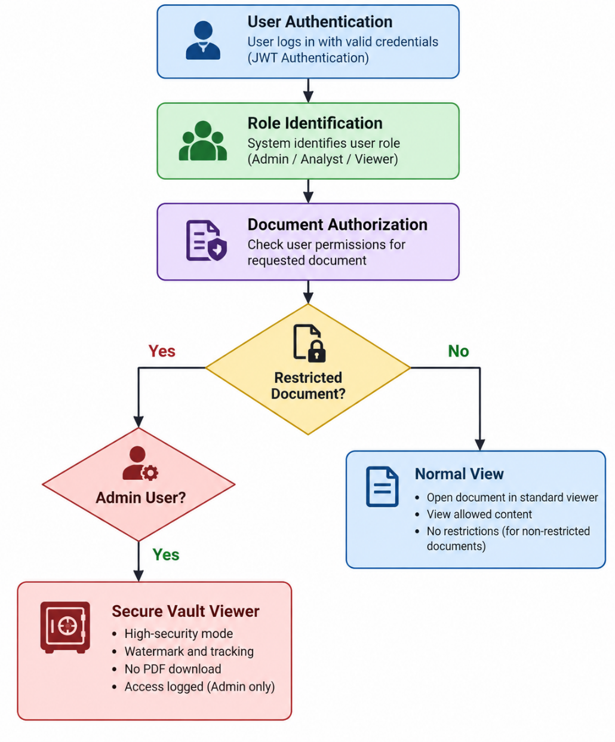
Figure 3: Zero-Trust Document Authorization and Secure Vault Viewer Workflow
(Source: Self-created)
Secure Vault Viewer
When an authorized administrator accesses a restricted document, the document is presented through a controlled internal viewer.
The viewer provides a high-security visual treatment, including:
- Restricted-access watermark.
- High-security visual indicators.
- Administrator access notification.
- Tracked document viewing.
- Disabled raw-PDF download.
The purpose is to ensure that sensitive content remains within the controlled application environment while still allowing authorized administrators to review it.
The Round 2 presentation explicitly describes restricted documents as hidden from standard analysts and states that raw PDFs cannot be downloaded through the secure viewer.

7.18 Identity-Aware Real-Time Audit Logging
The audit architecture has been enhanced to associate every important event with the authenticated user's identity.
The audit record can contain:
- User ID
- Username
- Role
- Action type
- Timestamp
- Request/activity information
- Status
The platform records events including:
- Search queries.
- Document views.
- Permission denials.
- Restricted-document access.
- Administrative corrections.
The resulting model is:
Authenticated User
↓
System Action
↓
Audit Middleware
↓
User ID + Role + Action + Timestamp
↓
Persistent Audit Store
↓
Analytics / Audit Dashboard
This enhancement eliminates ambiguity associated with anonymous activity records and provides a clearer audit trail for administrative review.
The Round 2 presentation demonstrates this through the Operational Analytics and Audit Drill-Down interface.

7.19 Traceable Policy Note Agent
The Policy Note Agent has been enhanced from a general policy-assistance function into a more structured document-generation workflow.
The enhanced workflow is:
Step 1 — Retrieve
The agent searches the knowledge base for relevant Government Orders and supporting policy documents.
Step 2 — Verify
The retrieved documents are checked against document status and lineage information to avoid relying on superseded material.
Step 3 — Extract
Relevant financial figures, clauses and supporting information are extracted from the retrieved sources.
Step 4 — Draft
The agent prepares a structured policy-note draft using the required Secretariat-style format.
Step 5 — Cite
The generated draft includes traceable source citations that allow users to inspect the underlying documents.
Step 6 — Review
A disclaimer and human-review stage make clear that the generated content is an assistance mechanism rather than an autonomous policy decision.
Therefore:
User Request
↓
Retrieve
↓
Verify Lineage
↓
Extract Evidence
↓
Generate Secretariat Draft
↓
Attach Citations
↓
Disclaimer
↓
Human Review
The Round 2 presentation describes the enhanced agent as retrieving active GOs, extracting financial figures and formatting the output into a Secretariat-style policy note.

7.20 GST Policy Assistant with Citation Linking
The GST Policy Assistant has been enhanced to improve source verification.
The assistant retrieves relevant GST policy information from the document knowledge base and provides the supporting source as a clickable citation.
The workflow is:
GST Query
↓
GST Agent
↓
Relevant Official Circular
↓
Policy / Rate Information
↓
Response
↓
Clickable Source Citation
For example, the Round 2 demonstration shows a GST response supported by an HSN code and a citation to Circular 34/2023.
This enables the official to move directly from the generated response to the source document for human verification.

7.21 Operational Analytics Dashboard
The Analytics and Audit functionality has been enhanced to provide an operational view of the platform.
The dashboard provides information such as:
- Total documents.
- Active orders.
- Superseded orders.
- Restricted documents.
- Query/activity information.
- Audit events.
- User identifiers.
- Action types.
- Timestamps.
The dashboard therefore combines operational metrics with audit information.
The Round 2 presentation describes this as an Operational Analytics & Audit Drill-Down capability and demonstrates real-time metrics and a tamper-evident audit log.

8. Testing and Validation

8.1 Test Strategy
Testing of Kerala Finance KIP was conducted across functional, security, integration and usability-related areas to validate both the original platform capabilities and the enhancements implemented for Round 2.
The testing strategy covers the complete document-intelligence lifecycle, beginning with document ingestion and classification and continuing through search, filtering, AI-assisted analysis, document access, policy assistance and audit monitoring.
The major testing areas are:
- Authentication Testing
- Authorization and RBAC Testing
- Document Ingestion Testing
- OCR and Native PDF Processing Testing
- Automated Document Classification Testing
- Confidence Scoring Testing
- Document Library Filtering Testing
- Hybrid Search Testing
- Voice Search Testing
- Document Lineage Testing
- Source Citation Testing
- Clause and Financial Figure Extraction Testing
- GST Assistant Testing
- Policy Note Agent Testing
- Secure Vault Viewer Testing
- Restricted Document Isolation Testing
- Identity-Aware Audit Logging Testing
- Operational Analytics Testing
- Error Handling Testing
- Integration Testing
- Deployment Testing
The automated test suite can be executed using:
make test
or through the API Gateway container using Pytest.
Testing was designed to verify not only whether individual features function correctly, but also whether security, document lineage, source traceability and user identity are preserved across the complete workflow.

8.2 Test Cases
Test ID | Test Case | Expected Result
TC01 | Valid user login | User successfully authenticated
TC02 | Invalid credentials | Authentication rejected
TC03 | Viewer accesses restricted document | Access denied
TC04 | Administrator accesses restricted document | Access permitted
TC05 | Analyst accesses permitted document | Access permitted
TC06 | Search query submitted | Relevant results returned
TC07 | Search result citation | Source label displayed
TC08 | Superseded document retrieved | Lineage status identified
TC09 | Superseded source used | System prevents inappropriate citation
TC10 | Analytics request | Relevant metrics returned
TC11 | Scanned PDF uploaded | OCR pipeline invoked
TC12 | Native PDF uploaded | Native PDF parser invoked
TC13 | Policy-agent request | Retrieve → Verify → Draft workflow executed
TC14 | Unauthorized administrative operation | Operation rejected
TC15 | Audit event generated | Action recorded
TC16 | New document uploaded for classification | Authority, Year, Subject and Document Type extracted
TC17 | High-confidence classification | Classification and confidence percentage displayed
TC18 | Low-confidence classification | Classification flagged for administrator review
TC19 | Administrator corrects classification | Corrected metadata stored and correction audited
TC20 | Filter documents by Document Type | Matching documents displayed
TC21 | Filter documents by Status | Active/Superseded documents filtered correctly
TC22 | Filter documents by Year | Documents from selected year displayed
TC23 | Combine multiple document filters | Only records matching selected criteria displayed
TC24 | Voice search query | Spoken query converted to searchable text locally
TC25 | Non-admin searches restricted content | Restricted document excluded
TC26 | Administrator opens restricted document | Secure Vault Viewer displayed
TC27 | Restricted document raw download attempted | Direct raw-PDF download prevented
TC28 | Document view performed | Authenticated user identity and timestamp recorded
TC29 | Policy Note Agent executed | Agent steps, policy note, disclaimer and citations returned
TC30 | GST query executed | Response includes clickable supporting citation
TC31 | Audit event generated | Correct User ID, role, action and timestamp recorded
TC32 | Analytics dashboard opened | Document and audit metrics displayed
TC33 | Permission denial occurs | Denial event recorded against authenticated user
TC34 | Restricted document excluded from AI context | Unauthorized AI interaction cannot retrieve restricted content
TC35 | Manual classification correction | Confidence updated to administrator-verified state and audit record created

8.3 Functional Testing
Functional testing was conducted to verify that the platform's core services and Round 2 enhancements operate according to their defined requirements.
The original platform functionality was validated for:
- Authentication.
- JWT-based access control.
- Role-based permissions.
- Document upload.
- OCR.
- Native PDF processing.
- Semantic indexing.
- BM25 keyword retrieval.
- Hybrid search.
- Reciprocal Rank Fusion.
- Document lineage.
- Source citations.
- Clause extraction.
- Financial figure extraction.
- GST assistance.
- Policy-note generation.
- Analytics.
The Round 2 functionality was additionally validated for:
Automated Classification
Uploaded documents are automatically processed to identify Authority, Year, Subject and Document Type.
Confidence Scoring
Classification results are accompanied by a confidence percentage, allowing administrators to identify classifications requiring review.
Advanced Filtering
The Document Library allows users to narrow document collections using multiple metadata filters.
Voice Search
Voice queries are converted into searchable text through the local speech interaction mechanism.
Secure Vault
Restricted documents are hidden from unauthorized users and accessed through the controlled administrator viewer.
Identity-Aware Auditing
System actions are associated with the authenticated user's identity rather than anonymous activity.
Policy Note Agent
The enhanced agent provides structured execution information, a Secretariat-style policy-note draft, disclaimer and source citations.
GST Assistant
GST responses provide direct source citations for verification.
Operational Analytics
The analytics interface provides document statistics and audit information.
The Round 2 presentation demonstrates these features through the Document Library, voice-search, Policy Agent, Secure Vault, GST Assistant and Operational Analytics interfaces.

8.4 Error Handling
The system implements controlled error handling across the document, search, AI and security workflows.
Potential error conditions include:
- Invalid credentials.
- Expired or invalid authentication tokens.
- Unauthorized requests.
- Restricted-document access attempts.
- Unsupported documents.
- OCR failures.
- PDF parsing errors.
- Missing metadata.
- Low-confidence document classifications.
- Search failures.
- Voice-recognition failures.
- LLM service failures.
- Database connection failures.
- Storage failures.
- Invalid API requests.
- Failed document-filter requests.
For classification-related failures, the platform can expose the classification for administrator review rather than treating uncertain metadata as authoritative.
For security-related failures, access is denied and the event is recorded in the audit trail.
For restricted-document requests, unauthorized users are prevented from accessing the document rather than being provided with the document and then denied at download level.

8.5 Performance Testing
Performance evaluation considers:
- Document ingestion time.
- OCR processing time.
- Classification processing time.
- Embedding generation time.
- Search latency.
- Hybrid retrieval latency.
- RRF reranking latency.
- Voice-query processing time.
- Policy-agent response time.
- GST Assistant response time.
- LLM response time.
- API response time.
- Document-filter response time.
- Analytics dashboard response time.
- Concurrent request behaviour.
Search/retrieval evaluation should be measured using an evaluation dataset containing predefined queries and expected relevant documents.
Recommended retrieval measures include:
- Precision@K.
- Recall@K.
- Hit Rate@K.
Mean Reciprocal Rank (MRR).
Response latency.
Where numerical measurements are not available from the current POC test run, they should not be presented as measured results. Instead, the evaluation methodology should be documented and actual values can be added when benchmark execution is completed.

9. Results and Evaluation

9.1 System Demonstration
The Round 2 version of Kerala Finance KIP demonstrates an extended end-to-end enterprise knowledge workflow:
Document Upload
↓
OCR / Native Parsing
↓
Automated Classification
↓
Confidence Scoring
↓
Metadata Indexing
↓
Document Library Filtering
↓
Hybrid Search / Voice Search
↓
Lineage Validation
↓
Local LLM / Policy Agent
↓
Source Citations
↓
Secure Access Control
↓
Identity-Aware Audit Logging
↓
Operational Analytics
The enhanced workflow demonstrates that the platform has progressed from a basic document-intelligence proof of concept to a more comprehensive enterprise-oriented knowledge platform.

9.2 Automated Document Ingestion Results
The Round 2 implementation introduces automatic classification during document ingestion.
The system extracts:
- Authority.
- Year.
- Subject.
- Document Type.
A confidence score is generated alongside the classification.
For example:
Authority: Government of Kerala
Year: 2023
Subject: Financial Administration
Document Type: Government Order
Confidence: 97%
Low-confidence classifications can be reviewed and corrected by administrators.
The Round 2 demonstration confirms that classification and confidence information are visible within the document-processing workflow.

9.3 Document Library and Filtering Results
The enhanced Document Library provides a structured method for navigating large document collections.
Users can apply filters based on supported document metadata, including:
- Document Type.
- Status.
- Year.
This reduces the dependency on free-text search when users already know relevant document characteristics.
The filtering functionality is particularly useful for distinguishing active and superseded documents and narrowing documents to a particular period.

9.4 Voice Search Results
The Search Documents interface includes a microphone-based voice interaction.
The workflow is:
Voice Input
↓
Local Speech Recognition
↓
Text Query
↓
Hybrid Search
↓
Results
The feature addresses the requirement for offline audio interaction and provides an alternative to manual keyboard-based query entry.
The Round 2 presentation demonstrates the microphone interaction directly within the Search Documents page.

9.5 Hybrid Search and Source-Aware Results
The platform continues to combine:
- ChromaDB semantic search.
- BM25 keyword search.
- Reciprocal Rank Fusion.
- Document lineage filtering.
The result is a hybrid retrieval workflow capable of handling both semantic questions and exact government-document terminology.
Source review information continues to provide:
- Document title.
- Page number.
- Status.
- Confidence.
- Match type.
- Lineage information.
This maintains traceability between generated responses and their underlying documents.

9.6 Policy Note Agent Results
The Round 2 Policy Note Agent extends the original Retrieve → Verify → Draft workflow.
The enhanced process is:
Retrieve
↓
Verify
↓
Extract
↓
Draft
↓
Cite
↓
Human Review
The generated result contains:
- Agent execution steps.
- Relevant source information.
- Extracted financial information.
- Secretariat-style policy-note draft.
- Disclaimer.
- Clickable citations.
The Round 2 presentation demonstrates a policy note based on active Government Orders and extracted financial information.

9.7 GST Assistant Results
The GST Assistant continues to provide GST policy research but now includes direct source verification.
The enhanced response provides:
- GST-related answer.
- Relevant policy information.
- HSN/rate information where applicable.
- Clickable source citation.
The Round 2 demonstration shows the citation linking to the relevant official circular/document, allowing the user to verify the answer against the underlying source.

9.8 Secure Vault and Zero-Trust Results
The Round 2 implementation strengthens restricted-document protection.
Restricted documents are hidden from unauthorized users rather than simply being protected after they have been displayed.
For authorized administrators, restricted content is presented through the Secure Vault Viewer.
The viewer provides:
- Restricted-access watermark.
- High-security visual indicators.
- Administrator access notification.
- Controlled document viewing.
- Access tracking.
- Disabled raw-PDF download.
This creates an additional protection layer around restricted government document.

9.9 Identity-Aware Audit Results
The audit system now associates events with the authenticated user.
A typical audit record contains:
Field | Example
User ID | admin_001
Role | Administrator
Action | DOCUMENT_VIEW
Timestamp | System timestamp
Status | SUCCESS

The enhanced audit mechanism provides improved traceability compared with anonymous activity records.

9.10 Operational Analytics Results
The Operational Analytics and Audit interface provides an administrative overview of platform activity.
The dashboard includes:
- Total Documents.
- Active Orders.
- Superseded Orders.
- Restricted Documents.
- User activity.
- Action types.
- Timestamps.
- Audit events.
The Round 2 presentation demonstrates this functionality through the Analytics & Audit interface.

9.11 Overall Round 2 Evaluation
Replace the old overall evaluation table with:
Capability | Round 2 Status
Document ingestion | Implemented
OCR | Implemented
Native PDF extraction | Implemented
Automated document classification | Implemented
Confidence scoring | Implemented
Advanced document filtering | Implemented
Semantic search | Implemented
BM25 search | Implemented
Hybrid search | Implemented
RRF reranking | Implemented
Document lineage | Implemented
Source citations | Implemented
Clause extraction | Implemented
Financial figure extraction | Implemented
GST Assistant | Implemented
GST clickable citations | Implemented
Policy Note Agent | Implemented
Secretariat-style policy draft | Implemented
Offline voice search | Implemented
JWT authentication | Implemented
RBAC | Implemented
Restricted document isolation | Implemented
Secure Vault Viewer | Implemented
Identity-aware audit logging | Implemented
Operational analytics | Implemented
Local LLM | Implemented
Local embeddings | Implemented
Docker Compose | Implemented
FastAPI/OpenAPI | Implemented
Automated testing | Implemented
This table gives you much stronger requirements-to-implementation traceability than the original Round 1 table.

10. Security, Privacy and Ethical Considerations

10.1 Zero-Trust Security Model
The Round 2 platform adopts a stronger Zero-Trust approach in which access to documents and platform functionality is explicitly verified according to the authenticated user's role and permissions.
Authentication alone does not provide access to every document. Authorization is evaluated before protected content is exposed.
The access model is:
User
↓
Authentication
↓
Identity Verification
↓
Role Identification
↓
Permission Check
↓
Document Classification Check
↓
Allow / Deny
This approach is particularly important for restricted government documents.

10.2 Restricted Document Isolation
Restricted documents are isolated from general document collections.
Non-administrative users cannot:
- See restricted documents in the Document Library.
- Retrieve restricted documents through normal search.
- Use restricted content as unauthorized AI context.
- Download restricted source PDFs.
This provides protection at the document-discovery stage rather than only at the document-opening stage.

10.3 Secure Vault Viewer
Authorized administrators can access restricted documents through a Secure Vault Viewer.
The viewer provides:
- Prominent RESTRICTED ACCESS visual marking.
- High-security interface indicators.
- Administrator access notification.
- Tracked document access.
- Controlled document rendering.
- Disabled raw-PDF download.
The purpose is to keep restricted content inside the application-controlled environment and reduce uncontrolled distribution of sensitive documents.
The Round 2 presentation explicitly demonstrates this secure-viewer workflow.

10.4 Authentication
JWT-based authentication is implemented at the API Gateway.
Protected services are accessed only after successful authentication.
Authentication provides the identity context required by subsequent authorization and audit processes.

10.5 Role-Based Access Control
The platform maintains three principal roles:
- Administrator.
- Analyst.
- Viewer.
The permissions are enforced at the API Gateway and relevant service boundaries.
Restricted documents are available only to authorized administrators.

10.6 Local AI and Data Privacy
The platform uses local Ollama-based LLM inference and local embedding generation.
Therefore:
- Government documents do not need to be sent to an external LLM provider.
- Search context remains within the controlled deployment.
- Embeddings are generated locally.
- AI processing can operate without external AI APIs.
This supports the platform's air-gapped/local-processing design.

10.7 Identity-Aware Audit Logging
The Round 2 audit mechanism associates events with the authenticated user's identity.
Logged information includes:
- User ID.
- Username.
- Role.
- Action.
- Timestamp.
- Event status.
Examples of auditable actions include:
- Document searches.
- Document views.
- Restricted-document access.
- Permission denials.
- Classification corrections.
- Administrative operations.
This creates a stronger accountability mechanism than anonymous logging.

10.8 Audit and Operational Monitoring
Audit events are surfaced through the Operational Analytics and Audit interface.
This allows authorized administrators to review activity such as:
- Who performed an action.
- What action was performed.
- When the action occurred.
- Whether the operation succeeded or was denied.

10.9 AI Reliability
AI-generated responses may still contain errors because LLM output depends on retrieval quality, document quality and model behaviour.
The platform reduces this risk through:
- Retrieval before generation.
- Source citations.
- Confidence information.
- Document status.
- Lineage filtering.
- Structured policy-agent workflows.
- Human review.
The AI system should therefore be treated as an assistance mechanism rather than an autonomous authority.

10.10 Ethical Considerations
The platform does not replace human responsibility for official government decisions.
Human review remains necessary for:
- Legal interpretation.
- Financial decisions.
- Policy approval.
- Official communications.
- Sensitive administrative decisions.
AI-generated policy notes and responses should be verified against authoritative source documents before formal use.

11. Limitations
Although the Round 2 implementation significantly extends the platform, several limitations remain.

11.1 OCR Accuracy
OCR accuracy can decline when documents contain poor-quality scans, unusual fonts, handwritten material, complex layouts or degraded pages.

11.2 Classification Accuracy
Automated document classification uses extraction and heuristic signals. Incorrect or incomplete document metadata may therefore result in an incorrect classification or lower confidence score.
Administrator review is available to correct such cases.

11.3 Speech Recognition Accuracy
Offline voice search depends on the quality of the user's microphone, pronunciation, environmental noise and the capabilities of the local speech-recognition mechanism.

11.4 Local LLM Resource Requirements
Running a local Llama model requires significant computational resources, particularly for concurrent users.

11.5 AI Response Accuracy
AI-generated responses can contain errors if the retrieval context is incomplete or ambiguous. Source verification and human review remain necessary.

11.6 Document Diversity
Government documents can contain varied layouts, tables, scanned images and formatting structures that may require specialized processing.

11.7 Search Evaluation Dataset
A larger benchmark dataset would be required to establish statistically robust retrieval performance across a production-scale document collection.

11.8 Lineage Data Quality
The accuracy of supersession detection depends on the completeness and correctness of the lineage information maintained within the system.

11.9 Voice Processing Coverage
Offline speech interaction may not provide the same language and accent coverage as large-scale cloud speech services.

11.10 Production Scalability
The current implementation is a locally deployable enterprise prototype. Production deployment across a large government organization would require additional infrastructure for high availability, monitoring, backup, disaster recovery and concurrent workloads.

11.11 Security Operational Controls
The software implements application-level access controls and audit mechanisms, but a production deployment would additionally require organizational security controls, infrastructure hardening, identity-management integration and formal security assessment.

12. Future Enhancements
The Round 2 platform establishes the foundation for expanding Kerala Finance KIP beyond the current prototype. Future development is structured into three phases.

12.1 Phase 1 — Current Enterprise-Ready Prototype
The current Round 2 implementation represents the first phase of the platform's evolution toward an enterprise-ready prototype.
The current phase includes:
- Document ingestion.
- OCR.
- Automated document classification.
- Confidence scoring.
- Advanced document filtering.
- Hybrid search.
- Document lineage.
- Source citations.
- Clause and financial figure extraction.
- GST Assistant.
- GST source citations.
- Policy Note Agent.
- Offline voice search.
- JWT authentication.
- RBAC.
- Restricted document isolation.
- Secure Vault Viewer.
- Identity-aware audit logging.
- Operational analytics.
- Local LLM inference.
- Local embeddings.
- Docker-based deployment.
- API-based microservice architecture.
The objective of Phase 1 is to demonstrate a secure and operational knowledge-intelligence platform suitable for controlled enterprise use.

12.2 Phase 2 — e-Office API Integration
The second phase would integrate Kerala Finance KIP with relevant government e-Office systems through controlled APIs.
Potential capabilities include:
- Automated document synchronization.
- Secure document ingestion from e-Office.
- Metadata synchronization.
- Government document status synchronization.
- Automated lineage updates.
- User identity integration.
- Workflow integration.
- Policy-note submission workflows.
- Document approval/status tracking.
The integration should preserve the platform's security and audit requirements and should use authenticated, controlled API contracts.

12.3 Phase 3 — State-Wide Expansion
The third phase would expand the platform from the Finance Department to wider state-government use.
Potential areas include:
- Additional government departments.
- Larger document collections.
- Department-specific knowledge repositories.
- Shared search infrastructure.
- Department-aware access control.
- State-level analytics.
- Multilingual document processing.
- Cross-department document lineage.
- Centralized monitoring.
- High-availability infrastructure.
- Backup and disaster recovery.
- Enterprise identity integration.
The state-wide architecture would require additional capacity planning and governance because the number of users, documents and access-control policies would increase significantly.

12.4 Roadmap Summary
PHASE 1
Current Enterprise-Ready Prototype
↓
PHASE 2
e-Office API Integration
↓
PHASE 3
State-Wide Expansion
This roadmap represents the transition from a controlled prototype to government-system integration and eventually broader state-level deployment.

13. Conclusion
Kerala Finance KIP has evolved from its Round 1 proof of concept into a more comprehensive enterprise-oriented knowledge intelligence platform. The Round 2 implementation strengthens the original document ingestion, OCR, hybrid search, document lineage, GST assistance and policy-note capabilities with several new features.
Automated document classification and confidence scoring improve metadata management, while advanced filtering makes large document collections easier to navigate. Offline voice search provides an additional interaction method without requiring cloud-based speech services. Security has been strengthened through Zero-Trust access control and the Secure Vault Viewer, ensuring that restricted documents remain hidden from unauthorized users and that administrator access is tracked.
The platform also provides identity-aware audit logging, allowing user actions to be associated with authenticated identities, roles and timestamps. The enhanced Policy Note Agent and GST Assistant provide traceable, clickable source citations, while the Operational Analytics Dashboard provides visibility into documents and system activity.
The current implementation establishes an enterprise-ready prototype foundation. Future development is planned through three phases: Phase 1 – current enterprise-ready prototype, Phase 2 – e-Office API integration, and Phase 3 – state-wide expansion. Overall, the platform demonstrates a secure, locally deployable and source-aware approach to government document intelligence and AI-assisted policy research.

14. References
Aceves, P. and Evans, J.A. (2023). Mobilizing conceptual spaces: How word embedding models can inform measurement and theory within organization science. Organization Science. doi:10.1287/orsc.2023.1686.
Arslan, H. (2022). End to end invoice processing application based on key fields extraction. IEEE Access, 10, pp.78398–78413. doi:10.1109/access.2022.3192828.
Chen, M., Tao, Z., Tang, W., Qin, T., Yang, R. and Zhu, C. (2024). Enhancing emergency decision-making with knowledge graphs and large language models. International Journal of Disaster Risk Reduction, 113, p.104804. doi:10.1016/j.ijdrr.2024.104804.

15. Appendices

Appendix A — Code Snippets
Important implementation snippets should be included in the final submission rather than the complete source code.
Recommended snippets include:
A.1 FastAPI Gateway
from fastapi import FastAPI
app = FastAPI (
title="Kerala Finance KIP API"
)

@app.get("/health")
def health():
return {"status": "healthy"}
A.2 Hybrid Search
semantic_results = vector_search(query)
keyword_results = bm25_search(query)

results = reciprocal_rank_fusion(
semantic_results,
keyword_results
)
A.3 Lineage Filtering
active_results = [
result
for result in results
if result.status != "SUPERSEDED"
]
A.4 Source Review Information
source = {
"document": document.title,
"page": chunk.page_number,
"status": document.status,
"confidence": confidence,
"match_type": "hybrid"
}
A.5 Automated Classification
classification = classify_document(text)

result = {
"authority": classification.authority,
"year": classification.year,
"subject": classification.subject,
"document_type": classification.document_type,
"confidence": classification.confidence
}
A.6 Confidence Handling
if admin_correction:
classification.confidence = 1.0
create_audit_event(
action="CLASSIFICATION_CORRECTION"
)

Appendix B — Additional Screenshots
B.1 GitHub Repository
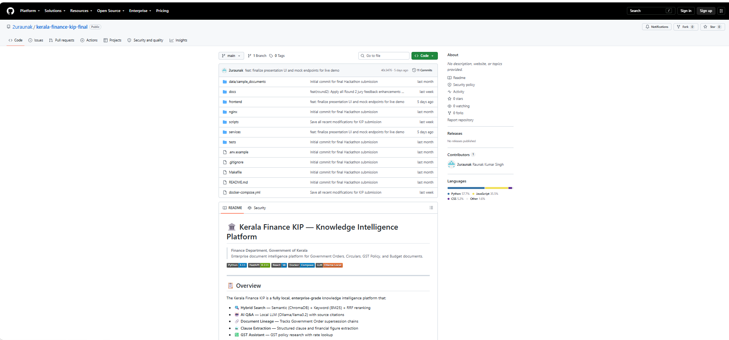
B.2 Application Dashboard
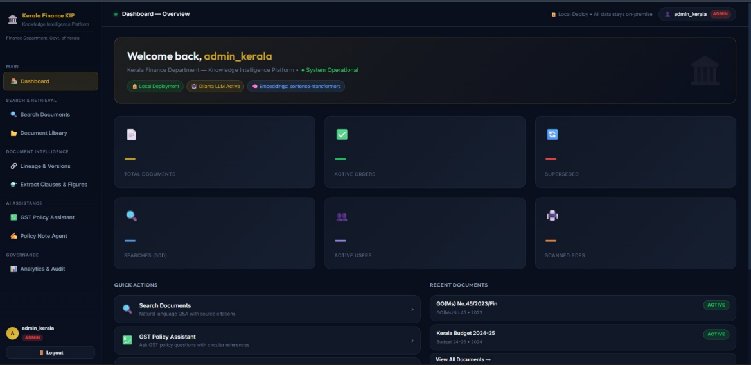
B.3 Sign in Page
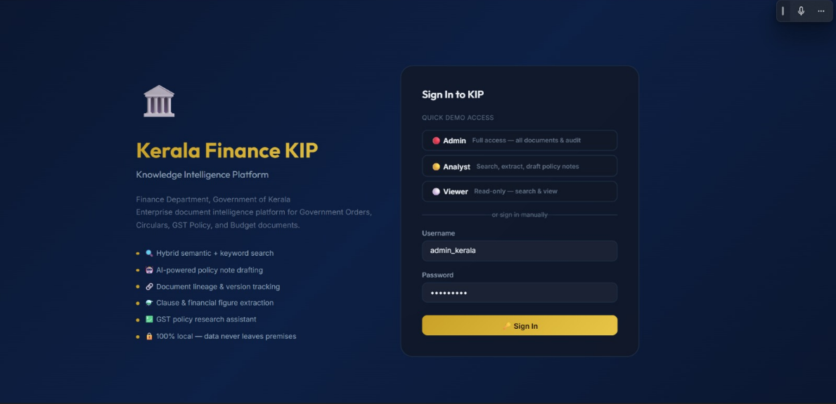
B.4 Intelligent Document Processing
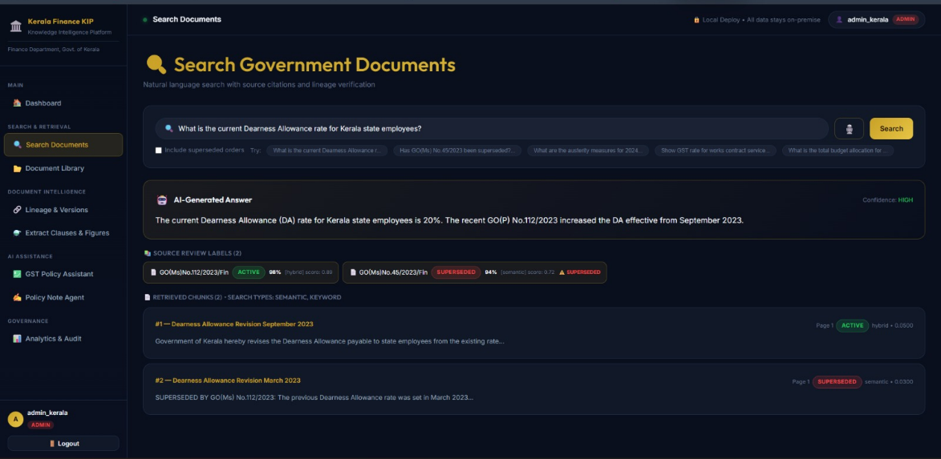
B.5 Document Library
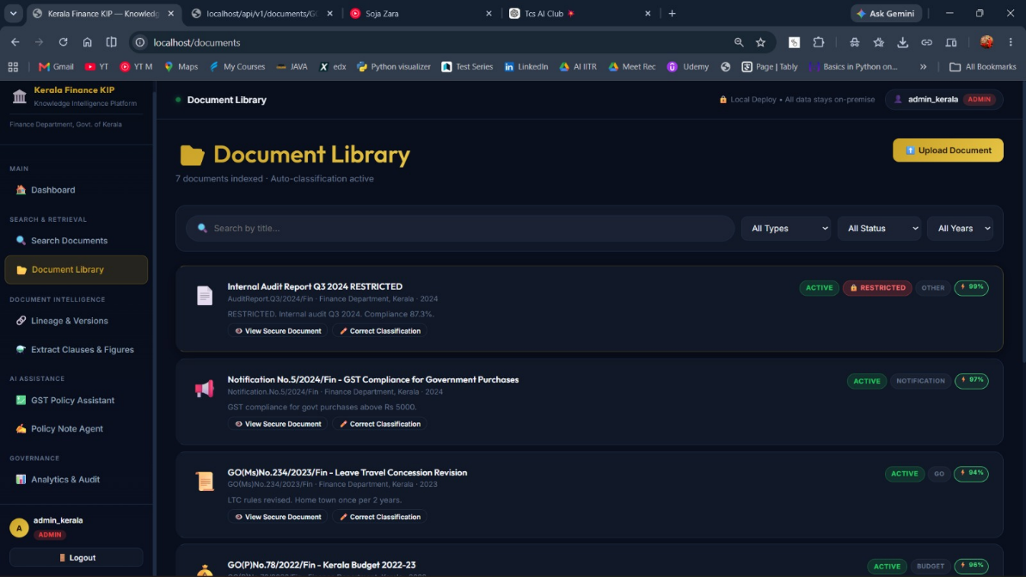
B.6 Voice Search
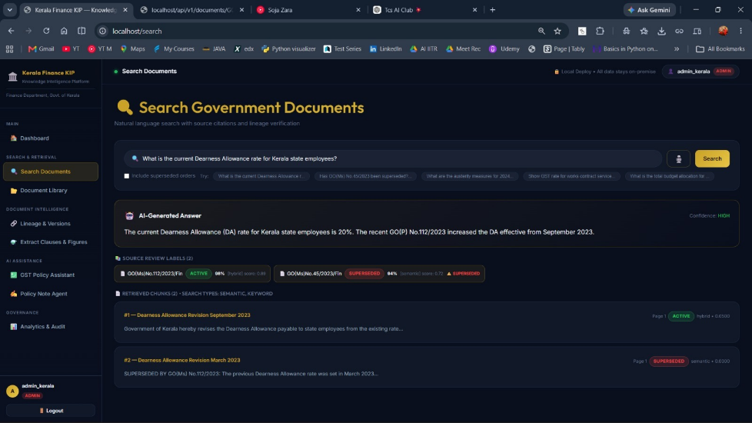
B.7 Policy Note Agent
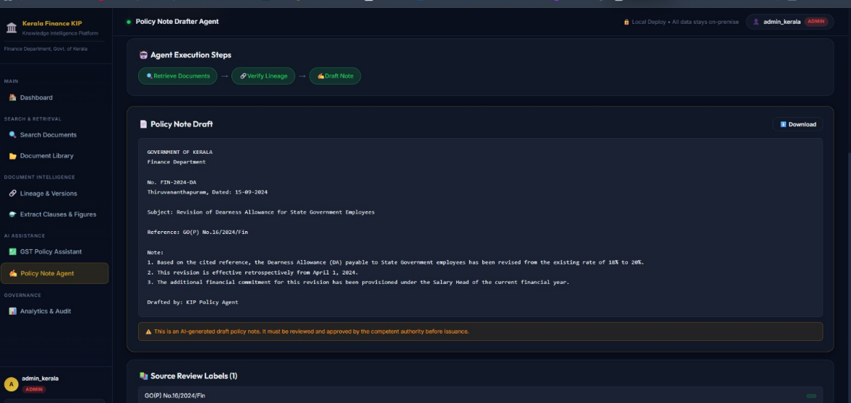
B.8 Secure Vault Viewer
B.9 GST Assistant
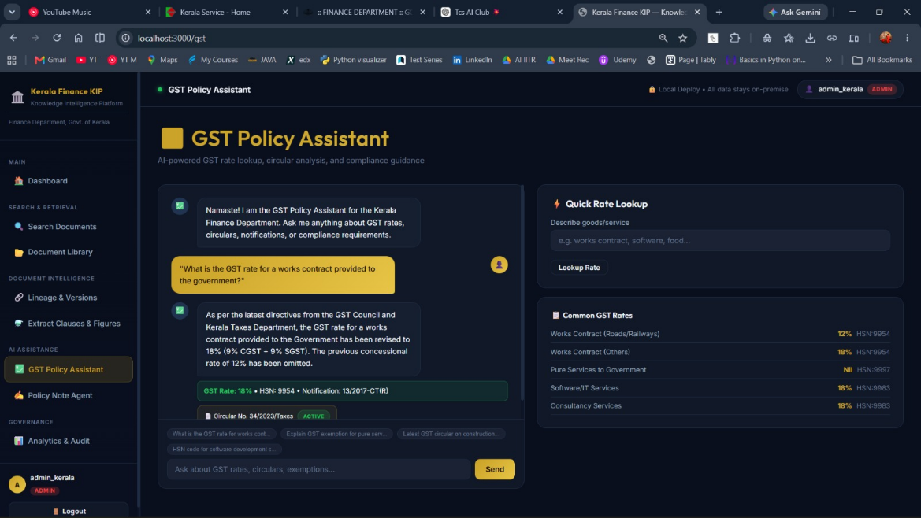
B.10 Operational Analytics & Audit
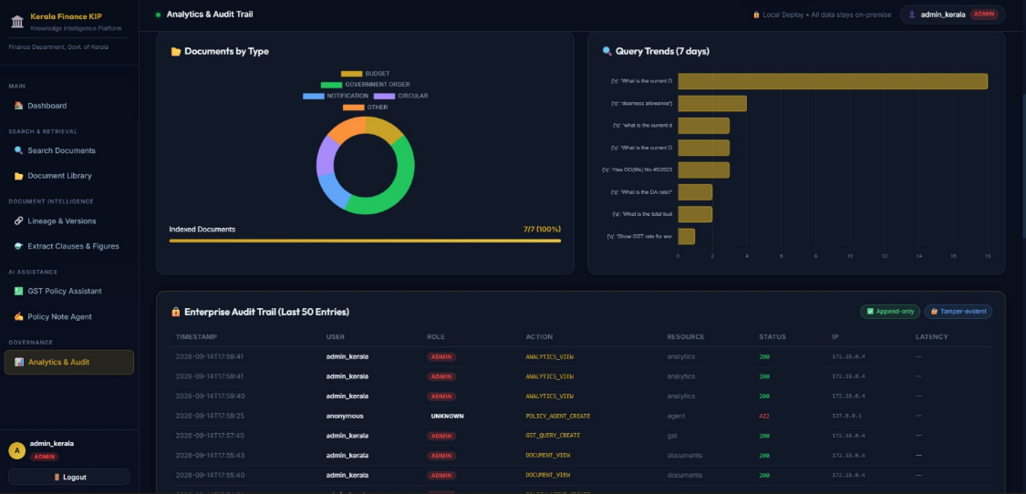

Appendix C — Configuration Details
C.1 Environment Configuration
The project provides an .env.example file.
Typical configuration categories include:
DATABASE_URL
REDIS_URL
MINIO_ENDPOINT
MINIO_ACCESS_KEY
MINIO_SECRET_KEY
CHROMA_HOST
OLLAMA_HOST
JWT_SECRET
Actual production secrets should never be committed to the repository.
C.2 Docker Deployment
The complete platform can be started using Docker Compose:
docker-compose up -d --build
The stack includes the major infrastructure components and application services.
C.3 LLM Setup
The local Llama model can be pulled through the configured Ollama service.
The project README specifies the model setup through the Makefile.
C.4 Sample Data
The repository includes sample Kerala Finance documents covering areas such as:
- Government Orders.
- Budget documents.
- GST documents.
- Office memoranda.
These documents can be used to demonstrate ingestion, indexing and search functionality.
C.5 Security Configuration
Document the relevant configuration categories for:
- JWT.
- RBAC.
- Restricted document handling.
- Audit logging.
- Local LLM.
- Local speech processing.

Appendix D — Sample Input and Output
D.1 Sample Search Input
What is the current Government Order regarding the applicable financial provision?
D.2 Sample Search Output
Answer: The current applicable provision is identified from the active
Government Order retrieved by the system.
Source: GO(Ms)No.112/2023/Fin

Page: 3
Status: ACTIVE
Confidence: HIGH
Match Type: HYBRID
Lineage Warning: FALSE
D.3 Sample Lineage Output
GO(Ms) No.45/2023/Fin
|
| SUPERSEDED BY
↓
GO(Ms) No.112/2023/Fin
|
↓
ACTIVE
D.4 Sample Policy-Agent Workflow
User Request
↓
Retrieve relevant Government Orders
↓
Verify document status
↓
Reject superseded sources
↓
Collect authoritative evidence
↓
Generate policy-note draft
↓
Attach source citations
↓
Human review
D.5 Classification Output
Authority: Government of Kerala
Year: 2023
Subject: Financial Administration
Document Type: Government Order
Confidence: 97%
D.6 Filtering Output
Document Type: Government Order
Status: ACTIVE
Year: 2023
→ Matching documents displayed
D.7 Voice Search Output
Voice Query:
"What is the applicable financial provision?"

Converted Query:
What is the applicable financial provision?

Search Results:
[Relevant Government Orders]
D.8 Secure Vault Output
Access Level: Administrator
Document Status: RESTRICTED
Viewer: Secure Vault
Raw Download: Disabled
Audit Status: LOGGED
D.9 Policy Note Output
Agent Execution
↓
Retrieved Sources
↓
Verified Active Sources
↓
Financial Evidence
↓
Secretariat Policy Note
↓
Disclaimer
↓
Citations
D.10 GST Assistant Output
GST Query
↓
Answer
↓
HSN / Rate Information
↓
Official Circular Citation
↓
Source Document

Appendix E — User Role Matrix
Function | Admin | Analyst | Viewer
Login | ✓ | ✓ | ✓
Search | ✓ | ✓ | ✓
View non-restricted documents | ✓ | ✓ | ✓
Access restricted documents | ✓ | ✗ | ✗
Secure Vault Viewer | ✓ | ✗ | ✗
Document classification review | ✓ | ✗ | ✗
Classification correction | ✓ | ✗ | ✗
Document filtering | ✓ | ✓ | ✓
Voice Search | ✓ | ✓ | ✓
Information extraction | ✓ | ✓ | ✗
GST Assistant | ✓ | ✓ | ✗
Policy Note Agent | ✓ | ✓ | ✗
Analytics | ✓ | Controlled | ✗
Audit Log | ✓ | Controlled | ✗
Administration | ✓ | ✗ | ✗

Appendix F — Main Platform Endpoints
The API Gateway is exposed through the FastAPI application.
The development environment provides API documentation through the OpenAPI/Swagger interface.
The main service structure includes:
API Gateway → 8000
Ingestion → 8001
Search → 8002
Lineage → 8003
Extraction → 8004
GST Agent → 8005
Policy Agent → 8006
Analytics → 8007
The React frontend operates on port 3000 in the documented development configuration. A note that the voice-search functionality, classification functionality, secure-document access and audit operations are exposed through the appropriate API/service boundaries rather than creating unnecessary standalone services, if that matches your implementation.

